7.85: a) For the given proposed potential 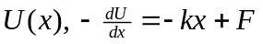, so this is a possible potential function. For this potential, 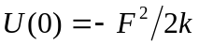, not zero. Setting the zero of potential is equivalent to adding a constant to the potential; any additive constant will not change the derivative, and will correspond to the same force. b) At equilibrium, the force is zero; solving 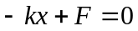 for x gives 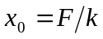. 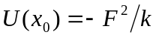, and this is a minimum of U, and hence a stable point.
c)
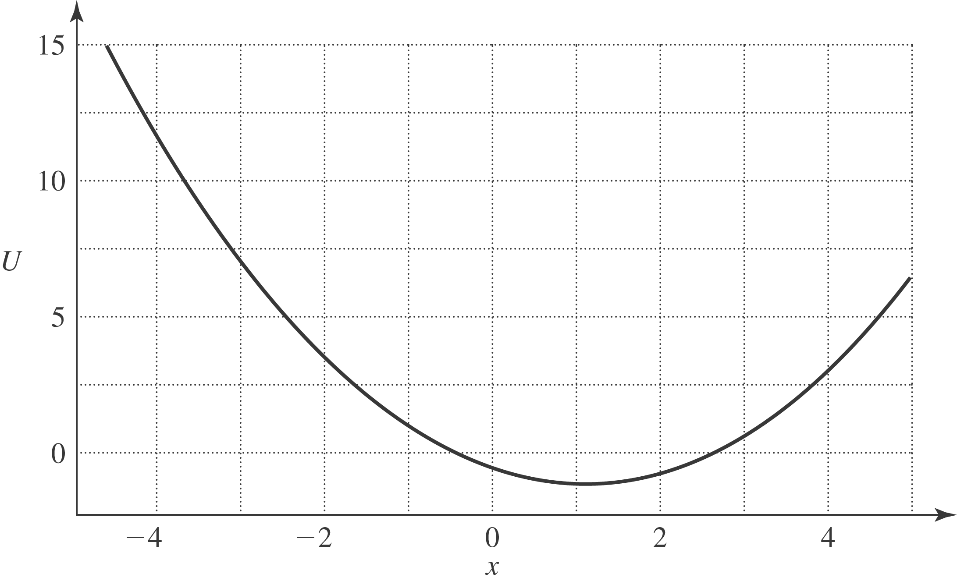
d) No; 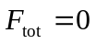 at only one point, and this is a stable point. e) The extreme values of x correspond to zero velocity, hence zero kinetic energy, so 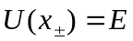, where 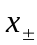 are the extreme points of the motion. Rather than solve a quadratic, note that 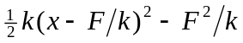, so becomes
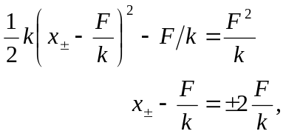
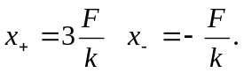

f) The maximum kinetic energy occurs when 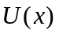 is a minimum, the point found in part (b). At this point , so 

